How to setup the Django app.

1. Go to the project folder => go to config folder => go to setings.py
2. Find this block of code to setup the DB. Paste data into the code block.

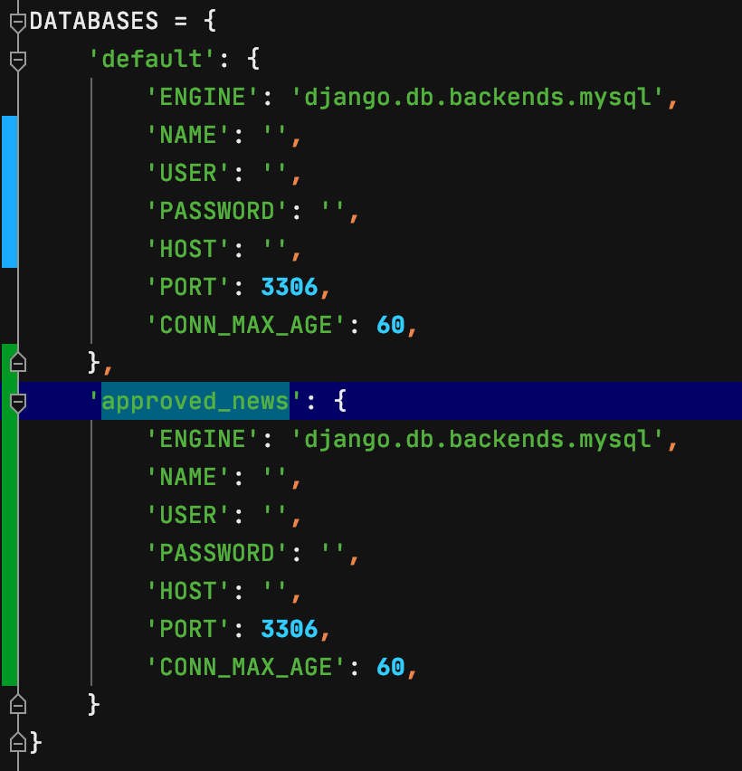

1. To set up EMAILs you have to do 3 steps.
2. Find the EMAIL host you want to use (for example, mailgun.com)
3. Easiest way to set up is by using SMTP(already pasted host as SMTP at mailgun).
4. Get you credential and insert them in this code block.

1. reCAPTCHA setup.
2. Go to <https://www.google.com/recaptcha/about/>
3. Go to admin console and create new reCAPTCHA v2
4. Paste keys in this code block.

